Information on tourist spots around Ojiya
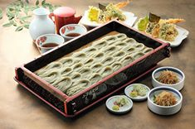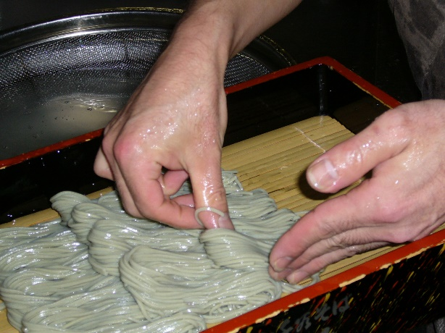
Ojiya Hegi-Soba noodle

Hegi-soba is one of the things Ojiya is famous for. We have many great Hegi-soba restaurants in Ojiya. The feature of Hegi-soba is “Funori” a type of seaweed which functions as glue making its toughness and unique flavor that you feel when it smoothly slides down your throat. The tasty flavor and its smooth texture to swallow will make you finish it easily. Funori has also been used in the process of making Ojiya-chijimi since before it was used for Hegi-soba.
The word “Hegi” comes from rectangular box made of cedar board called “Hegi” which Hegi-soba is served in. It is beautifully served in small pieces, and usually 3 or 4 people share one big Hegi-soba.
In Ojiya, when families get together or welcoming guests, lots of families serve Hegi-soba for them. Hegi-soba is the cuisine of Ojiya.
There are several famous Hegi-soba restaurants in Ojiya, and each restaurant has own characteristics in soup, side dish and relish. It will be fun to try all the restaurants!

